BIO-366; Original Paper 1. Kitamura, E., Blow, J. J., and Tanaka, T. U. (2006). Cell 125: 1297-1308
- What are the two opposing hypotheses being tested in this paper?
Hypothesis 1: The oppositely directed replication forks (each fork consists of two polymerase complexes; one for leading strand synthesis and the other for lagging strand synthesis) remain stationary. The DNA loci are pulled into the stationary replication factory, replicated and the daughter loci are extruded from the factory (see diagram below).

Fig. 1. The replication factory model. The stationary replication factory is shown here as the purple square. The green circle represents the origin and the red represents the terminus. The origin region replicates first, followed by the rest of the loci on the chromosome in a sequential fashion. The force of replication extrudes the daughter duplexes, while the adjacent yet to be replicated DNA enters the factory. The terminus region will be the last to be replicated.

Hypothesis 2. The replication forks move away from the origin and from each other in opposite directions as they replicate DNA. There is no stationary replication factory.

- What are the predictions that distinguish the two hypotheses that are testable by experiment?

- The stationary factory model predicts that two loci on either side of the origin and equidistant from it will come to the factory (or be pulled into the factory by the force of replication) at the same time. The only assumption here is that the rates of replication by the two forks (leftward and rightward) are the same.
- The moving replisome model does not predict that the two loci equidistant from the origin and on either side of it have to come together at the time of their replication. These loci will still replicate at the same time, assuming the same rate of fork movement in the leftward and rightward directions. The two loci remain essentially where they are (except for random Browninan movements within the nucleus); the leftward fork moves to the left locus; the rightward fork moves to the right focus. The two forks arrive at these loci at the same time, while the loci themselves remain apart.

- How can the stationary factory model be tested?

One has to be able to visualize the replication factory and also visualize a given DNA locus. In fact, one has to be able to visualize two DNA loci replicated by a single origin. These loci must be at the same distance from the origin and on either side of it. The question is: do the two loci arrive at the origin at the same time for replication?

- How can one view the replication factory in a live cell?

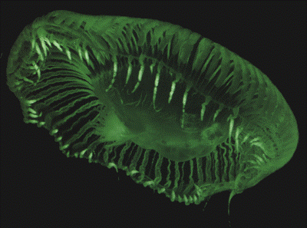
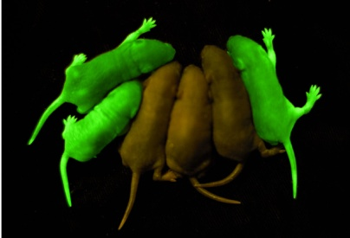
In living cells specific proteins can be labeled by fusing them to fluorescent proteins: GFP (green fluorescent protein); cyan fluorescent protein (CFP); YFP (yellow fluorescent protein); RFP (red fluorescent protein). The GFP-fusion proteins can be visualized by fluorescence microscopy. GFP was originally isolated from the jelly fish (Aequoria victoria). It can be expressed in bacteria, fungi, plants and vertebrates either as the native protein or fused (in frame) to a cellular protein of interest.

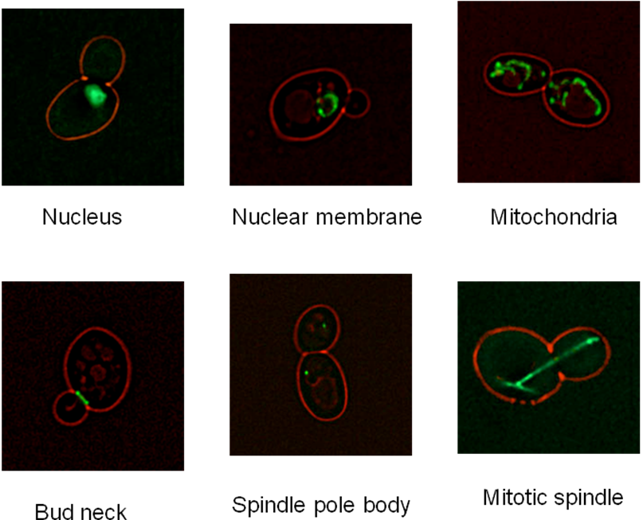
To visualize what might reasonably be a replication factory, one can fuse GFP to components of the replisome. In this study in Saccharomyces yeast, the gene for GFP is fused to POL1 (the gene for DNA polymerase alpha) or to POL2 (the gene for DNA polymerase epsilon) or to Pol4 (the gene for PCNA, the equivalent of the beta clamp that makes the polymerase processive).

Fig. 2. GFP-fusion proteins can be used to visualize specific cell components. The examples shown here are for the yeast Saccharomyces cerevisiae.
- How do we know that the green fluorescence we see from GFP-Pol alpha or GFP-Pol epsilon or GFP-PCNA in the cell nucleus indicates functional replication factories?

First, the fluorescent foci are formed at the time of bud emergence and a cell enters the S phase, and they remain as tight foci until completion of replication (metaphase), and they seem to disassemble.
Second, mutations that delay DNA synthesis (deletion of the mitotic cyclin genes CLB5 and CLB6) without affecting bud emergence also delay the formation of the fluorescent foci.
Third, when the firing of origins is suppressed by depleting the replication initiation factor Cdc6, the foci are either not formed or their number is greatly reduced.
Finally, when DNA synthesis is inhibited (slowed down significantly) using hydroxyurea (reduces the dNTP, deoxy-nucleotide triphosphate pools), the number of foci is sharply reduced.

- How can you view a DNA locus by fluorescence?
One can introduce a series of Lac operator casettes at a desired locus on a yeast chromosome by recombination. One can express GFP-Lac repressor in the cell containing the engineered chromosome, and target the fluorescent repressor to the nucleus. The GFP-repressor binds to the operators with high affinity and a long half-life. Hence the DNA locus displays green fluorescence, and appears as a green dot in the microscope.
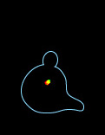
One can place a Tet (tetracycline) operator array at another DNA locus and express RFP (red)-Tet repressor or CFP (cyan)-Tet repressor to bind specifically to these operators. This locus will emit red or cyan fluorescence, depending on the particular tag on the repressor.

Note that the Lac-repressor binds only to the Lac operator array; the Tet-repressor to the Tet operator array; there is no cross-binding.

Fig. 3. Tagging DNA loci by fluorescence. Two plasmid molecules in the yeast nucleus are tagged by two different types of fluorescence: one by GFP-lac Repressor/LacO and the other by RFP-Tet repressor/TetO.

- How does one know that a particular DNA locus replicates at the replication factory that we visualized by GFP-Pol alpha or GFP-Pol epsilon or GFP-PCNA?

Let us start with cells in which the replication factory is tagged by green fluorescence and a DNA locus is tagged by cyan fluorescence (or red fluorescence). From previous genome wide mapping data in yeast, we know at what time and from which replication origin this locus replicates.
Let us arrest cells in G1 (with alpha factor) and then release them into the cell cycle by washing off the pheromone. Cells will then synchronously put out buds and enter into S phase (initiating DNA replication; the S phase lasts typically for about 60 min. in yeast). Let us look at individual cells to observe both the replication factory (green) and the DNA locus (cyan or red) as they go through the cell cycle.
We will follow the intensity of the cyan dot, and plot it as a function of time. At the time the dot replicates the intensity will double, and our microscopy is sensitive enough to pick up this two- fold change in intensity. We also ask how far or how close the cyan dot is from the green replication factory as the cell proceeds through the cell cycle. Is there a short time window just before or at the time of doubling of cyan (red) intensity that the cyan (red) dot becomes coincident with the factory? And the answer from the data with different cells is that, yes there is.
Since the replication factory occupies roughly 30% of the volume of the yeast nucleus, random chance would bring the cyan (red dot) to the replication factory at the time of its replication in roughly one third of the sampled cells . But if you see this happen in every cell that you observe, the probability that this occurrence is by random chance is statistically close to zero. In other words, the replication of a DNA locus happens at the replication factory. This is the conclusion from the data shown in the Figure below. The dashed line shows the 30% probability of coincidence of the DNA locus with the replication factory expected as a chance occurrence. The bars that rise above the dashed line are what interest us. Look high the bars are at the time the locus duplicates in fluorescence (time 0 min) or close to this time point. As we go farther away from the replication time, the coincidence of the locus and the factory drop to or below the chance value of 30%

- Having established that a DNA locus replicates (we can see the locus by fluorescence and note the time its replication by fluorescence doubling) at the factory (also seen by fluorescence), how will you test the stationary factory model?

We choose a replication origin (ARS) on chromosome V that we know replicates at 15-20 min in the S phase. We choose two loci, one to its left at 30 kbp (kilo base pairs) and the other to its right at 30 kbp. We tag one with cyan(red) fluorescence and the other with green fluorescence. Again previous studies tell us that these loci are replicated from the same origin (the one that fires at 15-20 min) and their replication time is approximately 40 min into the cell cycle.
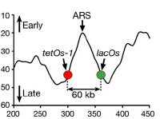

We confirm the above findings by a chromatin immunoprecipitation assay. When cells are released from G1, we feed them Br-dU (bromo-deoxyuridine), which can be incorporated in place of thymidine during DNA replication. The yeast strain we use has been engineered to express thymidine kinase, which is required to convert the Br-dU into its triphosphate form that can be utilized by DNA polymerase. At various times along the cell cycle, we take cell aliquots and shear the DNA into fragment of approximately 400 to 500 base pairs. We then add antibody to Br-dU that specifically immunoprecipitates replicated DNA, that is, DNA into which Br-dU has been incorporated during the S phase. We take the immunoprecipitated DNA, and do a PCR (polymerase chain reaction; a DNA amplification procedure) using DNA primers to the ARS (origin), the left locus and the right locus regions. For each reaction, we use two primers, one that hybridizes near the left end of a DNA region of interest and drives DNA synthesis rightward, and the other that hybridizes near the right end and drives DNA synthesis to the left. After multiple rounds of DNA synthesis, the amplified DNA will have a size defined by the distance in base pairs between the left and right primers. We can run out the PCR products on an agarose gel by electrophoresis, and test whether a DNA locus of interest to us has been amplified or not. If it is amplified , it means that the locus contains Br-dU or has been replicated. We find that the ARS region is immunoprecipitated by Br-dU antibody at around 15-20 min, and the left and right loci are immunoprecipitated later at around 40 min. These results give us confidence that we are looking at two loci replicated by one origin, the left locus being replicated by left replication fork and the right locus being replicated by the right replication fork. And consistent with their equal distance from the origin, they replicate at the same time (see Figure below).

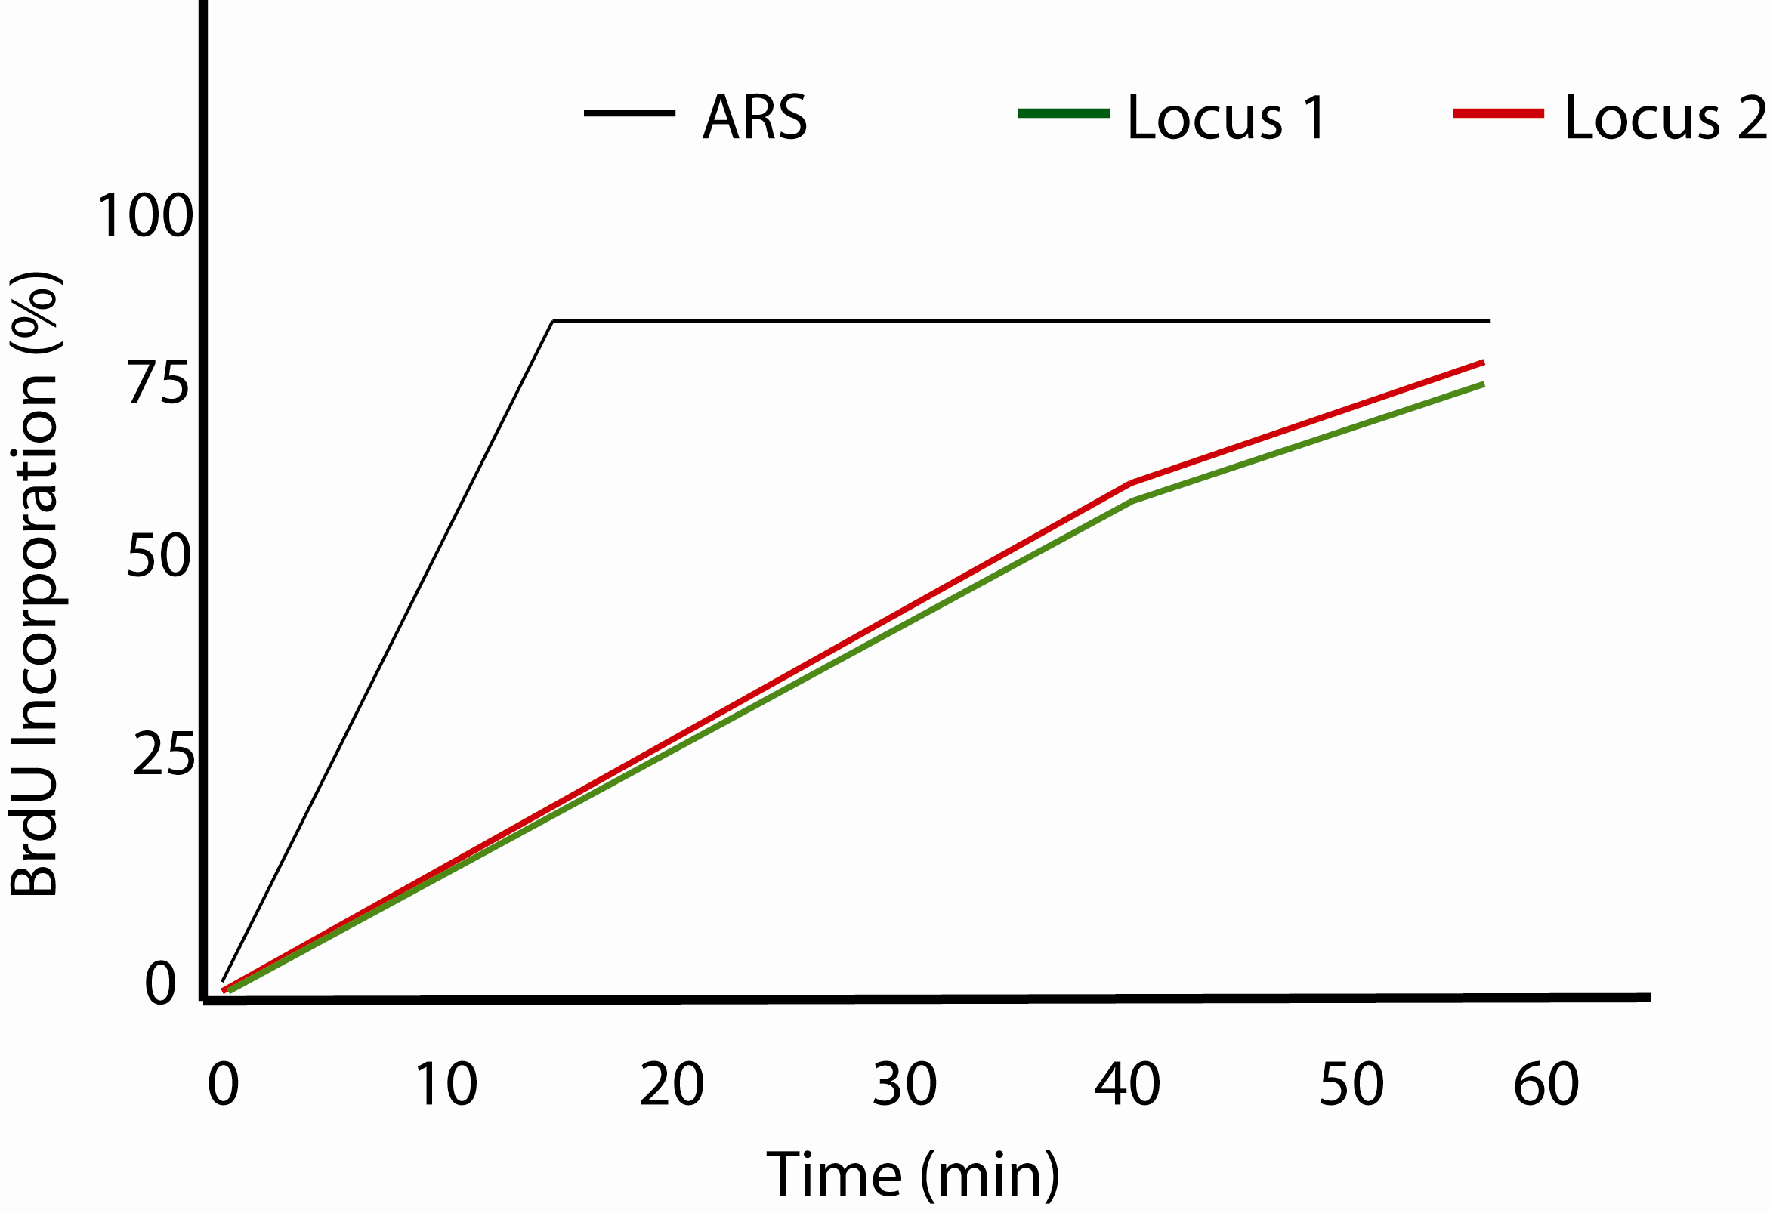

We also verify the above results by looking at the actual replication timings of the two fluorescent foci, one cyan (red) and the other green in a population of cells going through the cell cycle synchronously after release from G1. We simply classify cells into different classes. Class I: the green and cyan dot fluorescence corresponds to one copy of each locus (before replication; Class II: green has doubled in fluorescence but cyan has not; Class III: cyan has doubled in fluorescence but green has not; Class IV: both cyan and green have doubled in fluorescence; and Class V: cells in which chromosomes have segregated and each compartment shows green and cyan fluorescence equivalent to one copy each of the two loci. We plot the percentage of cells in the population that show these phenotypes at different times of the cell cycle. The result again shows that on an average at around 40-50 minutes, the vast majority of the cells are of the Class IV type, that is, both cyan and green loci have been replicated (see Figure below).
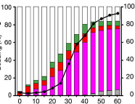

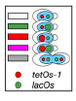

- Now the critical question: Since the cyan (red) and green loci replicate at the same time, do they come to the replication factory (and thus meet each other) at the same time for the act of replication?
To answer this question, we have to define what is colocalization of the two foci? We have to also define what is the mean replication time of the two loci?

Let us first observe the replication of the cyan (red) and green foci in a cell as S phase proceeds, and also measure their distances from each other at these time points. The data plotted below show that the two loci replicate at almost the same time, and they are closest to each other (less than 0.2 microns or 200 nm) from 3 min to 1 min (or a period of two min) before replication. In the Figure below, time 0 indicates the time at which both dots double in intensity (or both loci replicate) and -1, -2, -3 etc. indicate time points before this event (see also further explanation later).

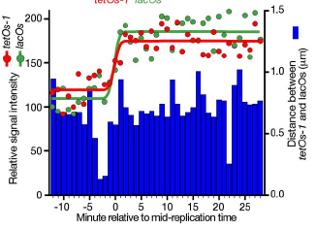

Let us repeat the assays for loci replication and loci colocalization using different individual cells. Remember that In these experiments, we are following the cells by time-lapse fluorescence microscopy as they get out of G1 and go through S phase.

We define co-localization as the two loci being at or less than 350 nm from each other for a length of 2 min or more.

As noted already, we define the replication time of the cyan locus when its intensity doubles (t1). We define the replication time of the green locus when its intensity doubles (t2). The mean replication time then is t1 + t2 divided by 2. We call this 0 min. the time intervals before the mean replication time can be represented by -1, -2, -3 min etc.; the time intervals following replication can be represented by +1, +2, +3min etc.

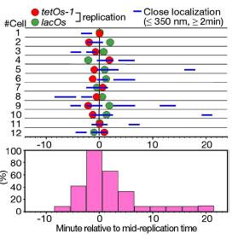

In the data for the individual cells from the paper (see Figure above), you will see that the line depicting 0 min (mean replication time) is spaced equally between the cyan (red) and green dots for each cell (the dots indicating the replication times of the two loci). The blue lines showing the colocalization of the two loci are present at 0 min or close to this time point in every cell tested. Co-localization of the cyan (red) and green loci at other time points (away from the 0 min line) occur rather haphazardly, indicating chance occurrences.
Conclusion: When the left and right loci are equidistant from an origin in between them that replicates the two loci, they converge at the time of their replication. As we know from our previous experiment, a DNA locus and the replication factory converge at the time at which the locus replicates. Putting the two observations together, we can say that the two DNA loci converge at the replication factory at the same time, and this is the time of their replication. THIS IS WHAT THE STATIOANRY FACTORY MODEL PREDICTS. THIS IS NOT WHAT THE MOVING REPLISOME MODEL PREDICTS.

- Finally, can we test a prediction of the stationary factory model that anticipates no convergence of two loci as they replicate? Or, how can we be sure that the convergence of loci we observed in the previous experiment is not an artifact of some sort? Can we see the replication of loci without them necessarily converging?
The conditions for convergence of two loci at the replication factory according to the stationary replisome model are : 1. the two loci must be equidistant from the origin; 2. For bidirectional replication, the two loci must be located on either side of the origin.

If the two loci are not replicated at the same time, they will not be at the replication factory at the same time, unless in a rare case random chance brings them together, This sort of convergence will not be correlated with the replication of either of the loci.

To establish the experimental set up that we need, let us move the green locus to the other side of the origin so that the distance between the origin and the red locus is the same as the distance between the red and the green loci. Or, the green locus is now twice as far away from the origin as the red locus, and both loci are on the same side of the origin. We repeat our experiments, following the replication times of each locus in individual cells, estimating the mean replication time (0 min), and mapping the colocalization of the loci ( 350 nm or closer for 2 min or longer) along the cell cycle.

You see from the data shown in the Figure below that for each cell, the 0 min line is spaced at a much larger distance from the cyan (red) and green dots than in the previous experiment, indicating that the cyan (red) locus replicates a lot earlier (being closer to the origin) than the green locus, which is farther away. And there is no correlation between the mean replication time and the colocalization of the two loci.

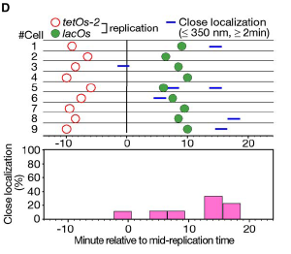

The result agrees with the prediction of the stationary replication factory model that when two loci are on the same side of the origin and replicate at different times they meet the factory at different times, corresponding to their individual times of replication and therefore do not converge at the factory at a fixed time.

